**Creating Datasets**

We need data sets to train test and execute the classifier which we need. Basically, as our Idea is detecting the wild animals and alerting people so that no harm for both living beings.

So as given the two datasets tiger and elephant, we can also add many different wild animal data sets that which we think they are somehow harmful and train test execute them. Training place major role. The increase in training results the increase in accuracy and efficiency of project (Specially in ML/AI).

***Static Execution***

**Training Datasets**

Generally, we have to train the data in a different manner because datasets are available in some sites like Kaggle. Since we can’t find our required animal we have to create on our own. Different platforms providing different large cloud to us. Using that we can train and test our project. We can also do it in laptop but that takes much time and there is a chance to decrease your laptop processing speed (< 4 GB GPU). So, we have to do it in cloud.

**IBM Training and Testing**

You must be an account holder of IBM Cloud

We have to train and test data initially the data is to be inserted into account. We are provided 250MB free storage in which we train and test.

***Dynamic Implementation***

Here the same IBM account creates a resource in visual recognition we have to use it. Every individual has his own ID called API KEY (in Manage Option)

That specific API key is to be added in the code.

As I kept my key in code use your key

***Note:*** If you already used the Visual recognition then the API key will be blocked for sure.

Don’t worry use a new mail and create an account in IBM and do the process again and run the code given.

As our Technology is AI Integrated with IoT

First, we have to run the train.py file. Use

Anaconda Software -> Spyder -> train.py -> (It takes time be patient) you will get a successful trained output

Spyder -> test.py -> (use web cam laptops only here we can execute as we need camera to detect that’s the key point. We have to give an input to this program that may be using phone or sheets or real time examples) you will get a accuracy rate that will be more than 90% if your data is trained well and with proper execution steps.

As we said it is integrated with IoT

We need Arduino and buzzer sensor that must be connected to your USB port. We also gave an IoT code file, connect this hardware and run that file using Arduino software. It runs successfully.

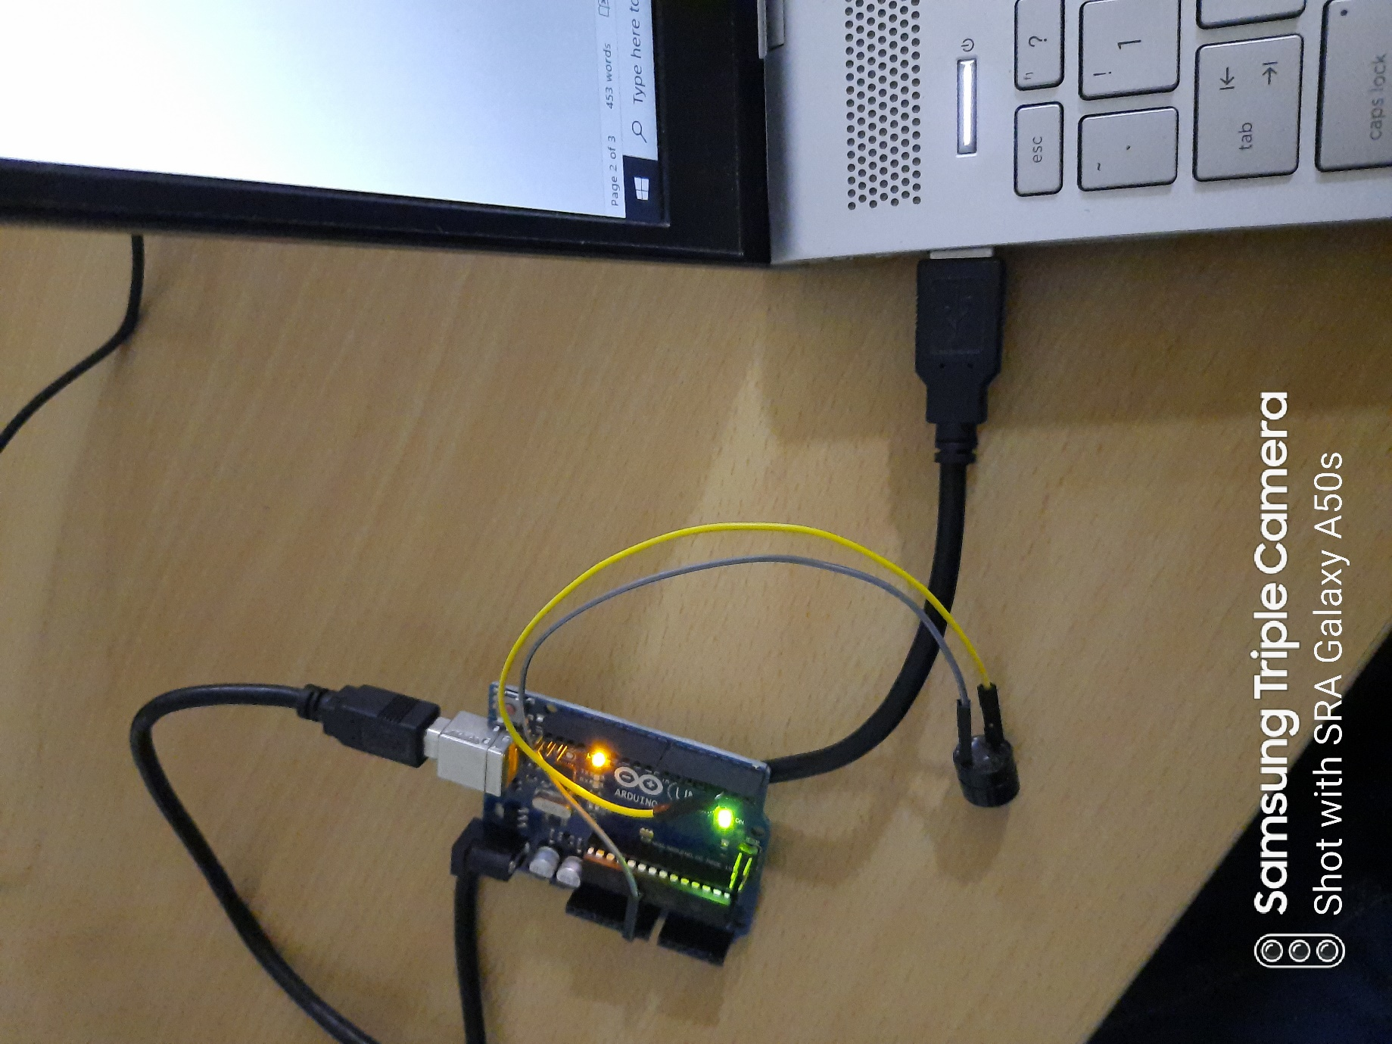

As you can see the files, we have

* IoT code
* Train Code
* Test Code

In test code we are giving a file which is for detection of the wild animal

Here the Hardware parts are used as

* After detection for the people alert, we used buzzer here. We can also make some sounds that deviates animals and makes people alert.
* And extension to it, after detection the next second the message is sent to Forest department. As per my convenience we used sender and receiver mails as same.

Check as per your trained data sets and use them.